Processing steps for Ana Maria’s glucose studies (10/29/2012)

1. Download MRI data from CNDA
2. Find out which scan is the T1/MPRAGE scan
3. Download the DICOM files that correspond to the MPRAGE scan in the study folder (under an MRI subdirectory, i.e. /data/nil-bluearc/hershey/unix/AMA/GluT/pXXXX)
4. Log in to super computer
5. Make folders for each study in /scratch/joann/freesurfer
6. Copy dicoms into super computer folders from cerbo: “scp * [joann@login1.chpc.wustl.edu:/scratch/joann/freesurfer/](mailto:joann@login1.chpc.wustl.edu:/scratch/joann/freesurfer/)”
7. Copy GLUT_XXXX.batch script to /scratch/joann/freesurfer: “scp GLUT_XXXX/GLUT_XXXX.batch [joann@login1.chpc.wustl.edu:/scratch/joann/freesurfer/](mailto:joann@login1.chpc.wustl.edu:/scratch/joann/freesurfer/)”

**Text in the GLUT_XXXX.batch file**

!/bin/sh

# give the job a name to help keep track of running jobs (optional)

#PBS -N GLUT_p7861

# Specify the resources needed

# We'll ask for 1 core of 1 node for 72 hours

#PBS -l nodes=1:ppn=1:idataplex,walltime=72:00:00,vmem=6gb

# Specify the default queue, not the SMP nodes

#PBS -q dque

# cd Into the run directory and get the data we need:

# cd /home/jmk1/freesurfer/subjects

# This is the directory will call the SUBJECTS_DIR

export SUBJECTS_DIR=/scratch/joann/freesurfer/subjects

# Make Freesurfer happy

export FREESURFER_HOME=/export/freesurfer-5.1

export PATH=${FREESURFER_HOME}/bin:${PATH}

export PATH=${FREESURFER_HOME}/mni/bin:${PATH}

export PERL5LIB=${FREESURFER_HOME}/mni/lib/perl5/5.8.5/

# Finally, run the commands

time recon-all -s GLUT_p7861 -i /scratch/joann/freesurfer/GLUT_p7861/p7861.MR.CCIR00400_CCIR-00437_Arbelaez.4.100.20110628.073812.b6vg9y.dcm -hippo-subfields -qcache –all

*change underlined portions for each pXXXX batch file thats specific for each subject ID

1. Run the script: “qsub GLUT_XXXX.batch”
2. Check status: “qstat jobID(s)”
   1. R =running, C=cancel, Q=pending
3. Check if freesurfer ran correctly:
   1. Type “cd subject_dir”
   2. Type “gedit GLUT_XXXX.oXXXX”
   3. Look for the phrase “finished without error” at the end of the file to verify that the subject was processed in entirety)
4. Download the subject folder that run on supercomputer (using a cerbo terminal):
   1. Make a freesurfer subdirectory and go to that subdirectory
   2. lftp sftp://joann@login1.chpc.wustl.edu
   3. cd into the subject directory (i.e. /scratch/joann/freesurfer/subjects)
   4. mirror GLUT_pXXXX (this will download the GLUT_XXXX folder into the cerbo subjects folder)
   5. quit
5. Double check that the folder was downloaded to cerbo
6. Type “chmod –R 7775 <directoryname>”
7. To check if Freesurfer segmented the brain correctly, use cerbo. On cerbo:
   1. Go to /data/nil-bluearc/hershey/unix/AMA/GluT/Freesurfer/pXXXX
   2. Type”setenv SUBJECTS_DIR /data/nil-bluearc/hershey/unix/AMA/GluT/Freesurfer/”
   3. tkmedit pXXXX brainmask.mgz –aux wm.mgz –surfs –seg aseg.mgz
   4. To turn off colors (in case you want to see something better”) do Ctrl-G
   5. Review segmentation on each orientation
   6. Alt-C will show you white matter - check temporal lobe
   7. To see segmentation with the skill and everything (not skull stripped like in this view), do (File – Load Aux Volume – subject file/mri/T1.mgz)
   8. To look at ICV issues (use tkregister2)

**Notes from Freesurfer tutorial:**

* Use supercomputer if possible
* Use “scp” command to copy files to the supercomputer
* Edit *.batch file to suit each study to be processed
* Recon_all is the freesurfer command that runs ALL of the tkm* commands that we’ll need from Freesurfer
* To make a file an executable file, do chmod 770 *.batch

1. Obtain PET data for each subject id using PET archives:
   1. Type “mkdir PET” (while in subject directory, i.e. /data/nil-bluearc/hershey/unix/AMA/GluT/p7861)
   2. Type “cd PET”
   3. Type “rlogin light”
   4. Type “arcfind pXXXX”
   5. Type “arcget pXXXX” (this will copy the PET files from the archives into the directory you’re currently in)
   6. Type “logout”
2. Convert the ECAT file (*.v) to 4dfp format
   1. Type “ecatto4dfp pXXXXgluc1.v pXXXXgluc1”
   2. Type “sum_pet_4dfp pXXXXgluc1 1 <last frame based on *ifh file> -h1223 pXXXXgluc1_sumall”
3. Register PET to MR
   1. Use “Bruckner” as your xterm
   2. Type “mkdir glucproc” (while in subject directory, i.e. /data/nil-bluearc/hershey/unix/AMA/GluT/p7861)
   3. Type “cp T1.mgz” – copy T1.mgz in freesurfer subdirectory into glucproc directory
   4. Type “cp pXXXXglucX.img” – copy pXXXXglucX.img in PET directory into the glucproc directory
   5. Copy the “mgzto4dfp” and “REGPETMR commands into glucproc from the /data/nil-bluearc/hershey/unix/AMA/GluT/suy_commands directory
   6. Type “mgzto4dfp T1.mgz”
   7. Type “REGPETMR pXXXXgluc1_sumall T1001”
4. Extract Tissue Activity Curves from chosen regions of interest (Whole Brain, Left Thalamus, Right Thalamus, Left Pallidum, Right Pallidum, Left Medial PFC, Right Medial PFC)
   1. Copy all of the commands in the /data/nil-bluearc/hershey/unix/AMA/GluT/suy_commands directory into the glucproc directory you are currently in. The following commands should be copied into the glucproc directory
      1. PreprocessRSFtest2
      2. Roieval
      3. Prepr*o*cfs
      4. Petinfo
      5. Gettacfs_4dfp
      6. Getcorttac
      7. ROIlist.txt
      8. Type “getgluctacs pXXXXgluc1”
5. Make an arterial blood data file using the command “blood” in the PET subdirectory. This only runs on petsun23. Type “blood pXXXX”. And then enter the arterial blood data obtained during the glucose PET. This should be in the patients’ study folder/files. This will produce a file named “pXXXX.dta”
6. Obtain well counter calibration factor.
   1. Log on to petsun23
   2. Use **betawel** to determine calibration factor (will need Beta Probe Cal Sheet from patient study and a *.crv file).
   3. Create a pXXXX.wel file in the directory
   4. Enter from Beta Probe Cal Sheet data. Make sure to press enter after each number is entered.
   5. Note well calibration factor (approximately around 20).
7. Check experimental log sheet for any unusual events.
8. Obtain plasma/whole blood data sheet taken during the study
9. Obtain the following arterial Blood Gas data:
   1. Mean hematocrit (Hct)
   2. Mean arterial oxygen content = Hb (approx. 13) x 0.951 (on sheet, it normally is 95.1) x 1.39
10. Obtain whole brain and cerebral blood flow data from the [ 15O]water PET scan.
    1. Make hoproc directory under study directory
    2. Copy pXXXXho*.v files to hoproc directory
    3. Make a “holist” text file using gedit that has the following information on line 1 (pXXXho1.v pXXXXho2.v)
    4. Type “regho pXXXX”
    5. Copy the gethotacs commands from /data/nil-bluearc/hershey/unix/AMA/GluT/suy_commands into the current directory
    6. Using Bruckner (not Xena or Petsun23), type “gethotacs holist pXXXX”
    7. Using Xena, type “/usr/local/bin/matlab” to launch matlab
    8. While in the matlab command window, type the following commands:
       1. addpath (‘/data/nil-bluearc/raichle/suy/GluT/matlabcode’);
       2. addpath (‘/data/nil-bluearc/hershey/unix/AMA/GluT /suy_commands’);
       3. CBFASAIFROI(‘pXXXXhoX’,pie factor,calibration factor) (i.e. (p7861ho1,4.88,20.283)
       4. From here, you should get the following values:
          1. CBFWBASARG (whole brain)
          2. CBFLMPFC
          3. CBFLPal
          4. CBFLThal
          5. CBFRMPFC
          6. CBFRPal
          7. CBFRThal
          8. CBFLOFC
          9. CBFROFC
    9. Enter these values into an excel spreadsheet as you will use them later.
11. Obtain whole brain and cerebral blood volume data from the [11CO] PET scan using petsun23.
    1. Use headstart to determine the start of frame 3 for non-dynamic studies (and note it) (headstart pXXXXoc1.r and headstart pXXXXoc2.r), usually 15.0
    2. Run betadcv for CO studies (betadcv pXXXXco1)
       1. Enter well calibration factor
       2. Y
       3. 1
       4. 2 – extension
       5. Hct value
       6. 2
       7. 2
       8. Y
       9. 12
       10. Dry syringe weight
       11. Wet syringe weight
       12. Time sampled
       13. Time counted
       14. Total counts
       15. Background counts
       16. Correction factor – 1.02379
       17. N
       18. Check each plot using plotcrv (plotcrv pXXXXoc1.crv)
    3. Run **makedta** to determine shifts in co curves
       1. p7861
       2. 1 (co)
       3. 2 (co)
       4. Oc1
       5. Enter
       6. Value from headstart on oc curve
       7. 3
       8. Enter
       9. Enter (no shift needed)
    4. Smooth co images using gauss of 0.3 (gauss p7861oc1.v 0.3)
    5. Run metproc on all emission studies (metproc p7861)
       1. enter
       2. _g3.v
       3. N
       4. Enter pie slope (which is 4.88 right now for 3D, but might change)
       5. Enter
       6. Enter
       7. Enter
    6. In the same directory (hoproc), copy over the pXXXXocX.v files from the PET directory and PETFOV, RSFMask, ROIlist.txt, and WBMask file from the glucproc directory.
    7. Run “regoc pXXXX” using xena
    8. Copy the getoctacs commands from /data/nil-bluearc/hershey/unix/AMA/GluT/suy_commands into the current directory
    9. Make a “oclist” text file using gedit that has the following information on line 1 (pXXXoc1.v pXXXXoc2.v)
    10. Using Bruckner (not Xena or Petsun23), type “getoctacs oclist pXXXX”
    11. Enter the following data into an excel spreadsheet
        1. P number
        2. Glucose scan
        3. CBV conversion factor (by typing “hdrinfo pXXXXoc1_g3.hdr” using petsun23)
        4. Headstart time (by typing “headstart pXXXXoc1.r” in petsun23)
        5. Start time and dcf (by typing “petinfo pXXXXoc1 1” in xena and then opening pXXXXoc1.info using gedit)
           1. First value = Start time
           2. Second value = Midpoint
           3. Third value = Frame duration
           4. Fourth value = decay factor based on a start time of zero (dcf)
    12. Pet counts for pXXXXocX scan from the following files (open using gedit). The last value under “mean” is the mean PET counts for that specific region
        1. pXXXXocX_ctx-lh-rostralanteriorcingulate.tac
        2. pXXXXocX_ctx-rh-rostralanteriorcingulate.tac
        3. pXXXXocX_Left-Pallidum.tac
        4. pXXXXocX_Left-Thalamus-Proper.tac
        5. pXXXXocX_Right-Pallidum.tac
        6. pXXXXocX_Right-Thalamus-Proper.tac
        7. pXXXXocX_ctx-lh-lateralorbitofrontal.tac
        8. pXXXXocX_ctx-rh-lateralorbitofrontal.tac
    13. Compute df, which based on a half-life of 122.24, is = (1/2)^(headstart/122.24)
    14. CBV will be computed as (CBV conversion factor*PET counts*0.3)/(dcf*df)
12. Obtain the K1 and Ki values for whole brain and the different regions using the Powers 4-compartmental model
    1. Edit the following *tac files in glucproc (using excel) so that is has the following text as: the first line (’30 decay-corrected activity), second line (# of PET frames, usually 43, and # of columns of data, 3). The next lines of data will correspond to the tissue activity curve data, with the first column indicating the start time, the second column indicating the frame duration, and the third column indicating the total tissue activity. The total tissue activity = (values in the last column of the *tac files obtained using getgluctacs*frame duration (third column of the *tac files)/3.42 (which is a correction factor)
       1. pXXXXglucX_ctx-lh-rostralanteriorcingulate.tac
       2. pXXXXglucX_ctx-rh-rostralanteriorcingulate.tac
       3. pXXXXglucX_Left-Pallidum.tac
       4. pXXXXglucX_Left-Thalamus-Proper.tac
       5. pXXXXglucX_Right-Pallidum.tac
       6. pXXXXglucX_Right-Thalamus-Proper.tac
       7. pXXXXglucX_ctx-lh-lateralorbitofrontal.tac
       8. pXXXXglucX_ctx-rh-lateralorbitofrontal.tac
    2. So it will look like this:

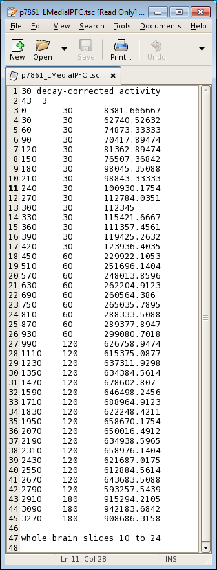

* 1. Copy and paste the data using gedit into a *tsc file that can be read by Dr. Power’s glucsun.run script. Note the name of the file in the example above.
  2. Copy the glucsun.run and glucnoflow.tsk programs from /data/nil-bluearc/hershey/unix/AMA/GluT/wjp_old_studies/p5661/wjp into glucproc.
  3. Copy the pXXXX.dta file from the PET subdirectory to the glucproc subdirectory
  4. Make the following files using gedit (examples of these files at the end of this manual):
     1. pXXXX_(region name).in
     2. pXXXX_(region name).job
     3. pXXXX_(region name).pbl
  5. On petsun23, type “csh pXXXX_(region name).job”
  6. The results will be in pXXXX_(region name)a.log (open using gedit in xena or textedit in petsun23)
  7. Values to take note are K-21, K-12, K-32, K-43, T0, Glucose Met (CMRGlc), Forward Flux (CTXGlc), Brain Free Gluc, and Utilization Fraction. Make sure the Weighted Sum of Squares value is <10 and RMSE is <1. Also make sure that column 1 and row 2 are NOT highly correlated (i.e. 0.99). If the values don’t make sense, that means there is something wrong with the data entered.
  8. Type “plotglu” and then enter “pXXXX_(region name)b.log” in petsun23 to make sure that the brain and blood curves look reasonable.

pXXXX_(region name).in looks like this:

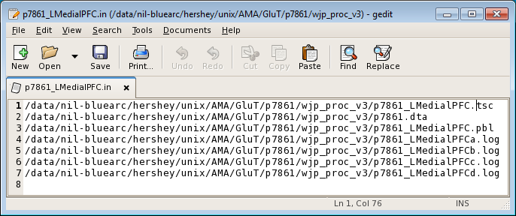

The log files at the end are your output files. This file also specifies which input files it will need to run the program (*tsc, *dta, and *pbl files)

pXXXX_(region name).job looks like this:

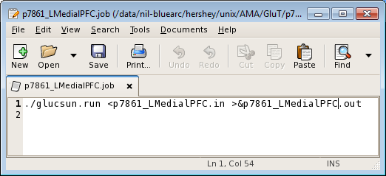

pXXXX_(region name).pbl looks like this:

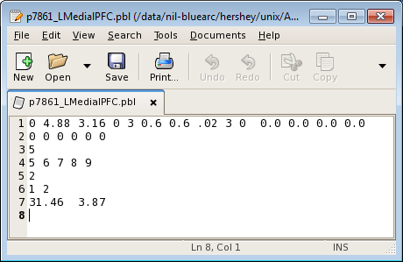

4.88 – pie factor

3.16 – whole blood glucose concentration, which is = Plasma Glucose (1-.3*Hct) in mmol/L

3 – Time delay between blood curve and brain tissue activity curve (from makedta)

0.6,0.6,0.02,3 – initial estimates of K21, K12, K32, and K43 in the 4-compartment model

5 - # of parameters to be estimated

5 6 7 8 9 – designates which values in the first line are to be estimated

2 - # of parameters with regional values which will be specified below

1 2 - designates which values in the first line have regional values that are to be specified below

31.46 – Cerebral Blood Flow (CBF) – from water (ho) scan

3.87 – Cerebral Blood Volume (CBV) – from co scan

4 compartment model

**Compartment 1:** represents free glucose in the vascular space which can exchange freely with free glucose in the brain.

**Compartment 2:** represents free glucose in the brain.

**Compartment 3:** represents glucose metabolites in the brain.

**Compartment 4 :** represents the vascular space to which metabolites go after they leave the brain.

**T0:** is time shift between arrival of radioactivity at the radial artery (sampling site) and the brain.

**C*1(t):** is the cerebrovascular time-activity curve for [1-11C]-D-glucose

**k*04:** cerebral blood flow/cerebral blood volume.

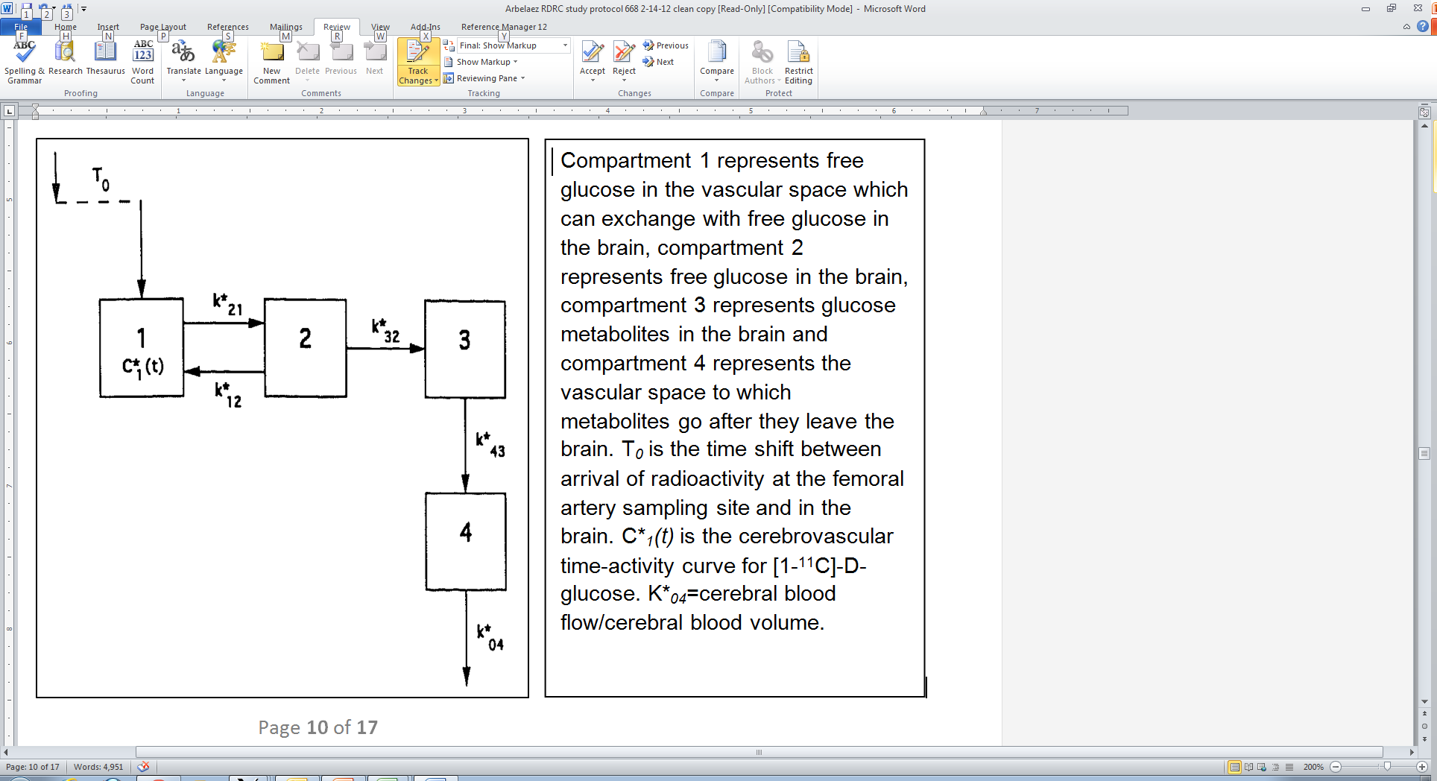

Output from plotglu will look like this (line is model fit, x are actual data points)

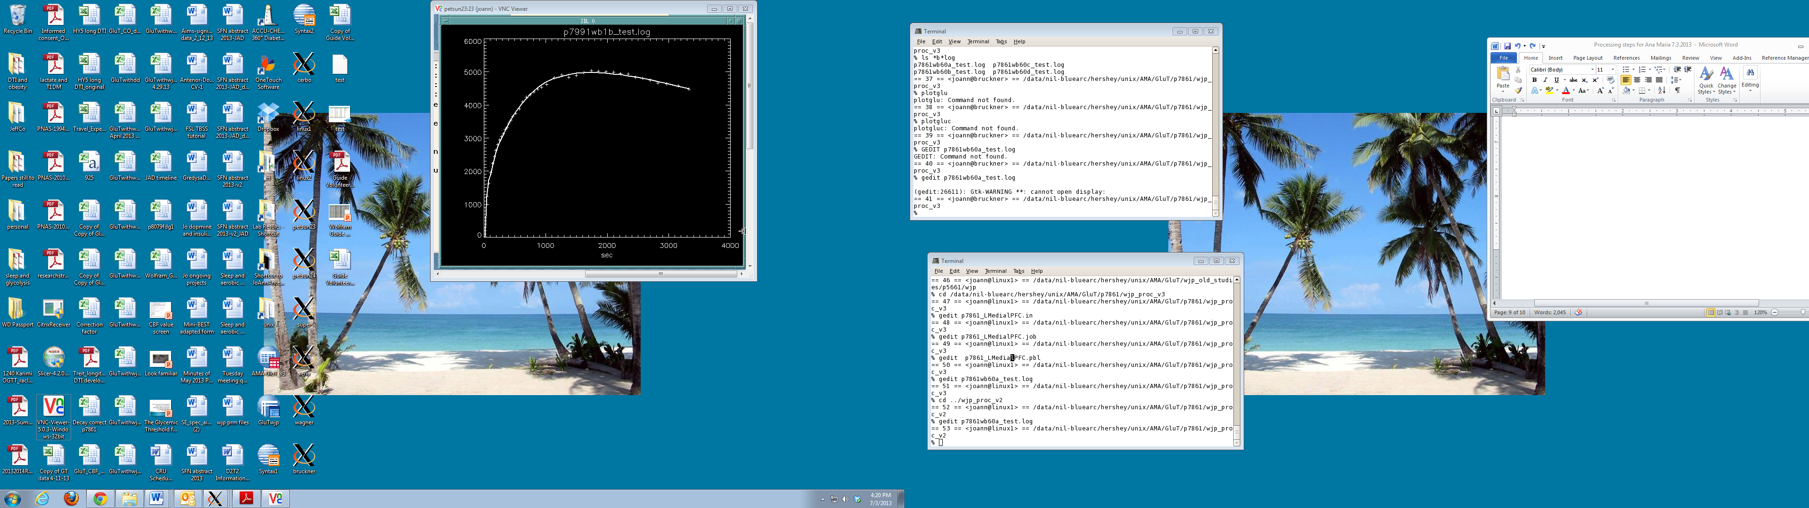

The *a* file will look like this

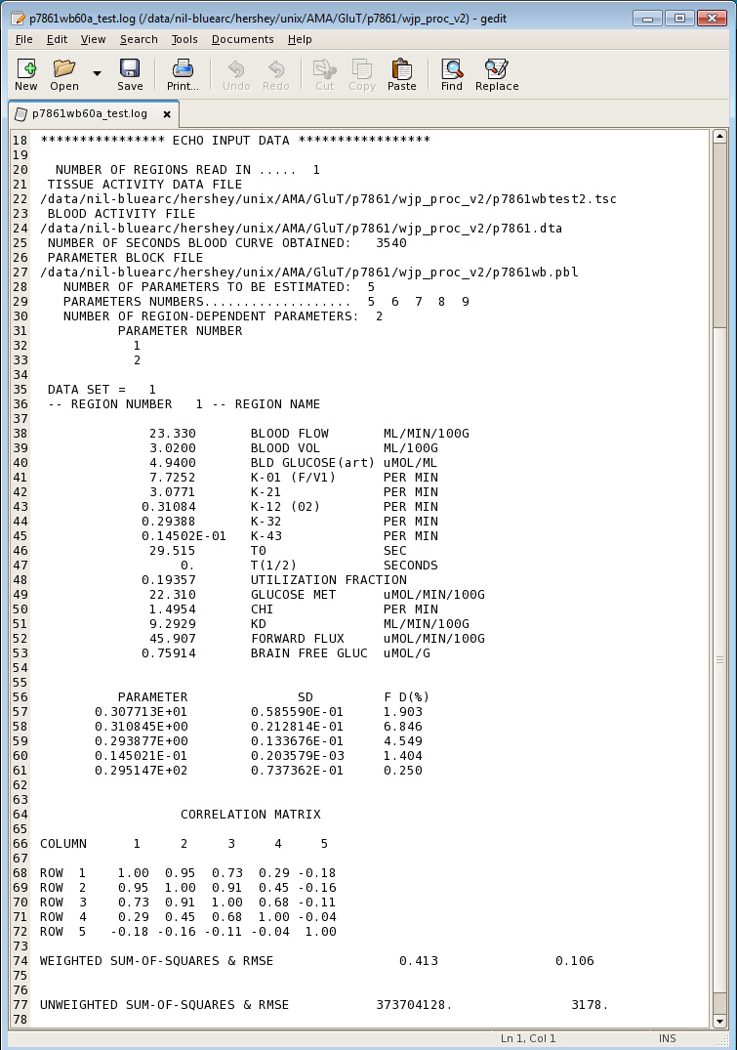

* 4.88 is the pie factor correction for the ECAT HR+ scanner in 3D mode For 2D mode, it will be 5.35

Appendix:

To extract the CMRGlc and CTXGlc values from the **hypothalamus**, we will be using an average hypothalamic region previously defined on a group of healthy subjects and aligned to the 222 atlas.

1. While in the glucproc directory, type:

“cp /data/nil-bluearc/hershey/unix/nmb_freesurfer/hypothal_average/nmb_controls_avg_hypothal_t0p5_222* .”

1. To check if the average hypothalamic region does correspond to the patients’ hypothalamic region, type the following commands:

t4img_4dfp T1001_to_CAPIIO_t4 T1001 T1001_222 -O222

nifti_4dfp -n T1001_222.4dfp.img T1001_222.nii

1. Check to see if the nmb_controls_avg_hypothal_t0p5_222 region fits well with the nmb_controls_avg_hypothal_t0p5_222 file using 3D-slicer
2. To check using vidi, convert the *4dfp* files into analyze format and then open the files in vidi.

4dfptoanalyze T1001_222 -@b

4dfptoanalyze nmb_controls_avg_hypothal_t0p5_222 -@b

1. If this looks good, then go ahead and create a new t4 file to place the PETs in 222 space

t4_mul pXXXXglucX_sumall_to_MR_t4 T1001_to_CAPIIO_t4 pXXXXglucX_sumall_to_CAPIIO_t4

t4img_4dfp pXXXXglucX_sumall_to_CAPIIO_t4 pXXXXglucX_sumall pXXXXglucX_sumall_222 –O222

nifti_4dfp –n pXXXXglucX_sumall_222.4dfp.img pXXXXglucX_sumall_222.nii

4dfptoanalyze pXXXXglucX_sumall_222 -@b

1. Check in either 3D slicer or vidi that the MRI and the PET looked aligned and that the hypothalamic regions plops on the PET reasonably well also.
2. Now, do this realignment on the actual dynamic glucose PET

t4img_4dfp pXXXXglucX_sumall_to_CAPIIO_t4 pXXXXglucX pXXXXglucX_222 –O222

1. Extract the tissue activity curve from the hypothalamic region

touch pXXXXglucX_hypothal.tac

qnt_4dfp pXXXXglucX_222 nmb_controls_avg_hypothal_t0p5_222 | gawk '/Mean/ {print $2}' >> pXXXXglucX_hypothal.tac

gedit pXXXXglucX_hypothal.tac (to make sure it worked)

1. Do the same thing to the ho and oc scans.

HO scan:

t4_mul pXXXXhoX_sumall_to_MR_t4 T1001_to_CAPIIO_t4 pXXXXhoX_sumall_to_CAPIIO_t4

t4img_4dfp pXXXXhoX_sumall_to_CAPIIO_t4 pXXXXhoX_sumall p7861hoX_sumall_222 -O222

4dfptoanalyze pXXXXhoX_sumall_222 -@b

nifti_4dfp –n pXXXXglucX_sumall_222.4dfp.img pXXXXglucX_sumall_222.nii

t4img_4dfp pXXXXhoX_sumall_to_CAPIIO_t4 pXXXXhoX pXXXXhoX_222 -O222

touch pXXXXhoX_hypothal.tac

qnt_4dfp pXXXXhoX_222 nmb_controls_avg_hypothal_t0p5_222 | gawk '/Mean/ {print $2}' >> pXXXXhoX_hypothal.tac

gedit pXXXXhoX_hypothal.tac &

CO scan:

t4_mul pXXXXocX_to_MR_t4 T1001_to_CAPIIO_t4 pXXXXoc1_to_CAPIIO_t4

t4img_4dfp pXXXXocX_to_CAPIIO_t4 pXXXXocX pXXXXocX_222 -O222

touch pXXXXocX_hypothal.tac

qnt_4dfp pXXXXocX_222 nmb_controls_avg_hypothal_t0p5_222 | gawk '/Mean/ {print $2}' >> pXXXXocX_hypothal.tac

gedit pXXXXocX_hypothal.tac

1. Re-run CBFASAIFROI.m in xena using Matlab to get the CBF value for the hypothalamus, and enter the tissue activity value from pXXXXocX_hypothal.tac into the CBV template excel spreadsheet you already have started to compute CBV
2. Make sure to convert the pXXXXglucX_hypothal.tac file into the pXXXXglucX_hypothal.tsc file format needed to run the job file that runs the glucsunrun command in petsun23 (similar to what has been done for the previous regions/studies).

Edit hypothal region

1. Edit region using vidi or vidivoi
2. Rename files generated to drop “4dint” portion
3. Analyzeto4dtp
4. Jump to number 7.